**DEVOPS TRAINING**

DAY 2

Setp 01: create a repository in github.

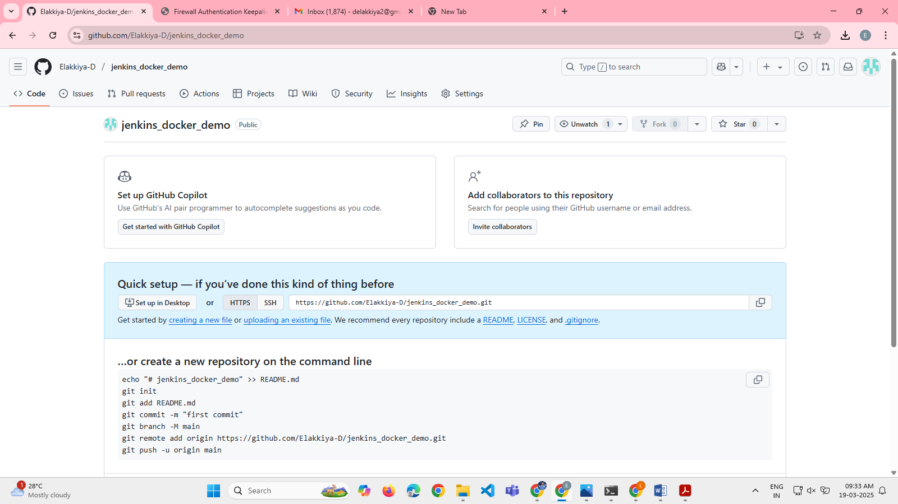

Step 02:go to developer settings

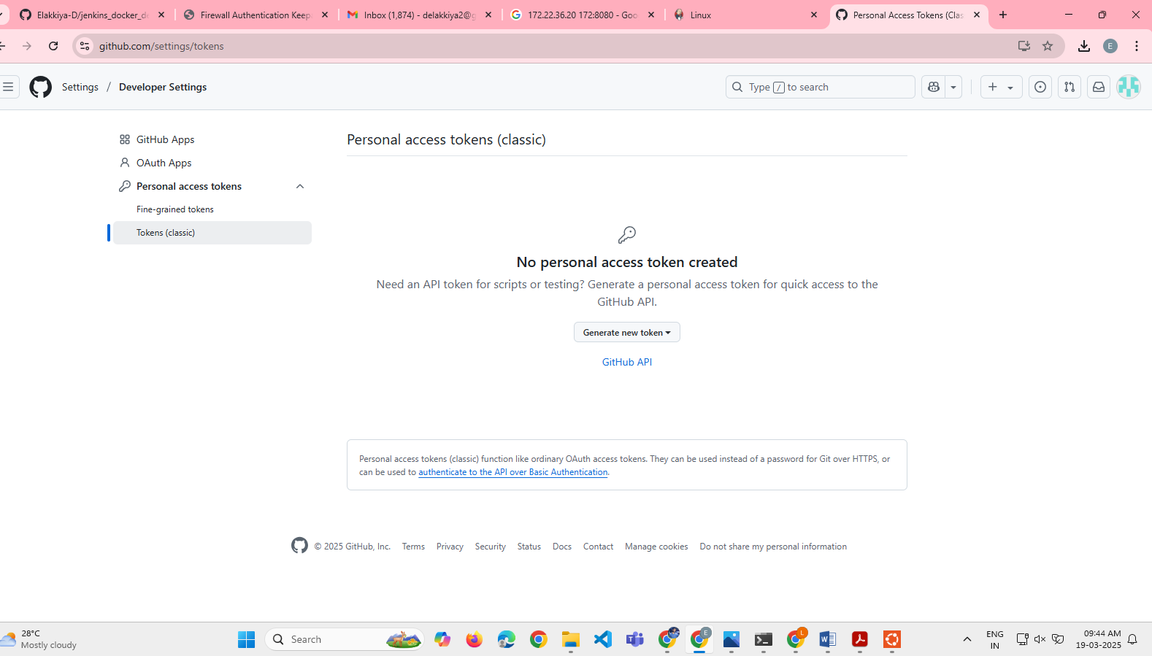

Step 03:generate and copy the Tokens(classic)

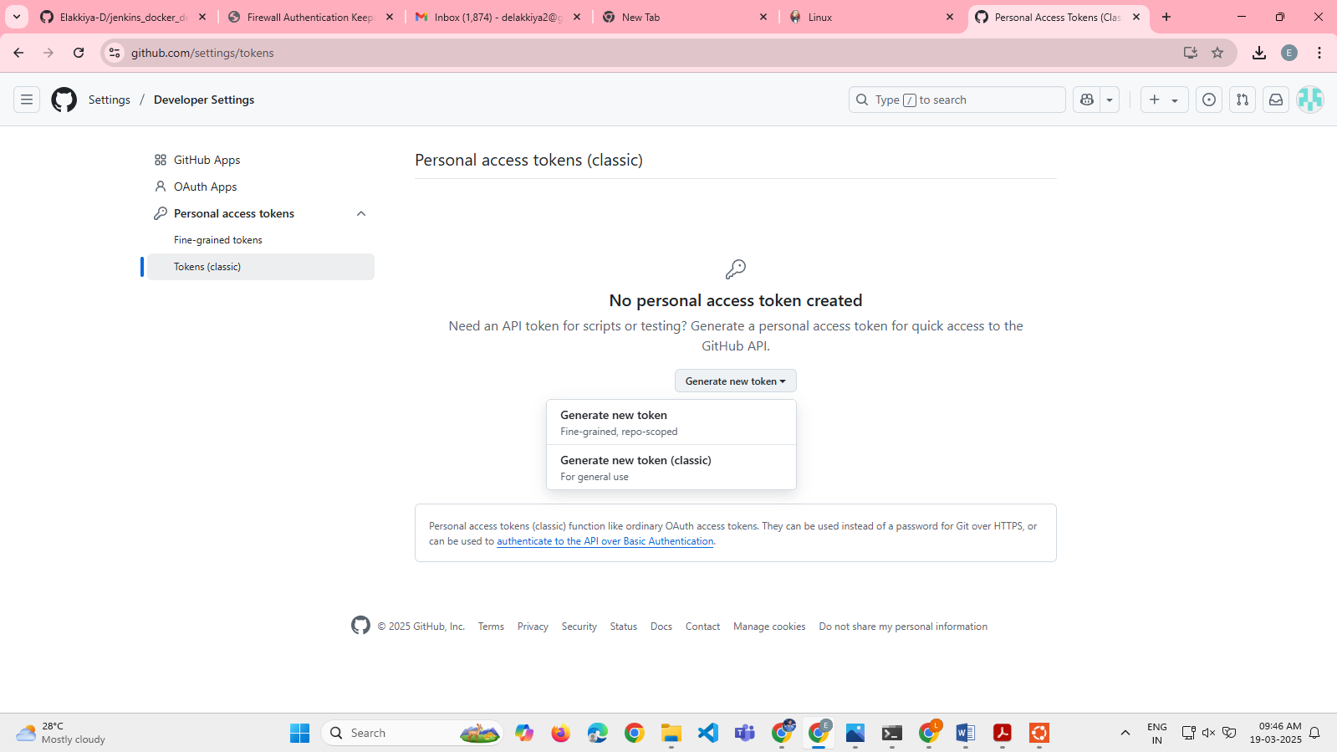

Click Generate new token (classic) and add a note

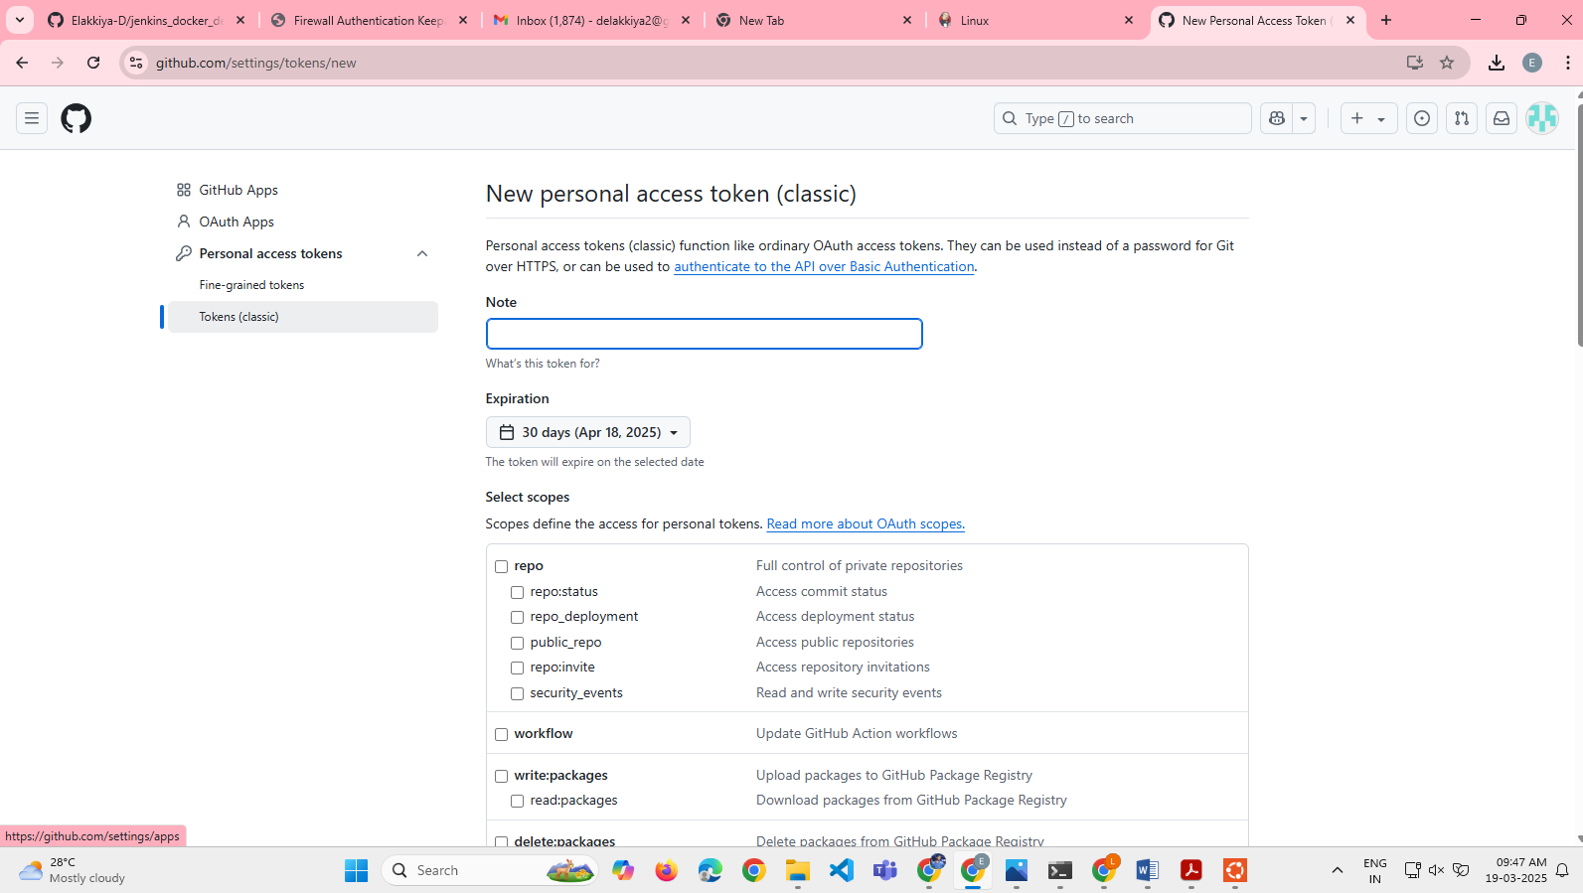

Step 4: open Jenkins and create new item and select pipeline in that go to configuration add github repository url into it

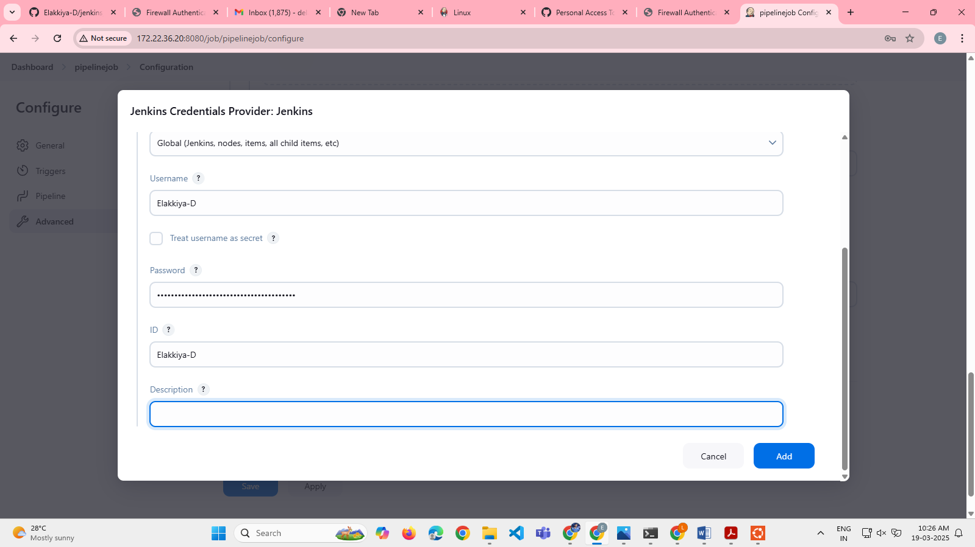

Select Repo,wlokflow,admin:repo_hook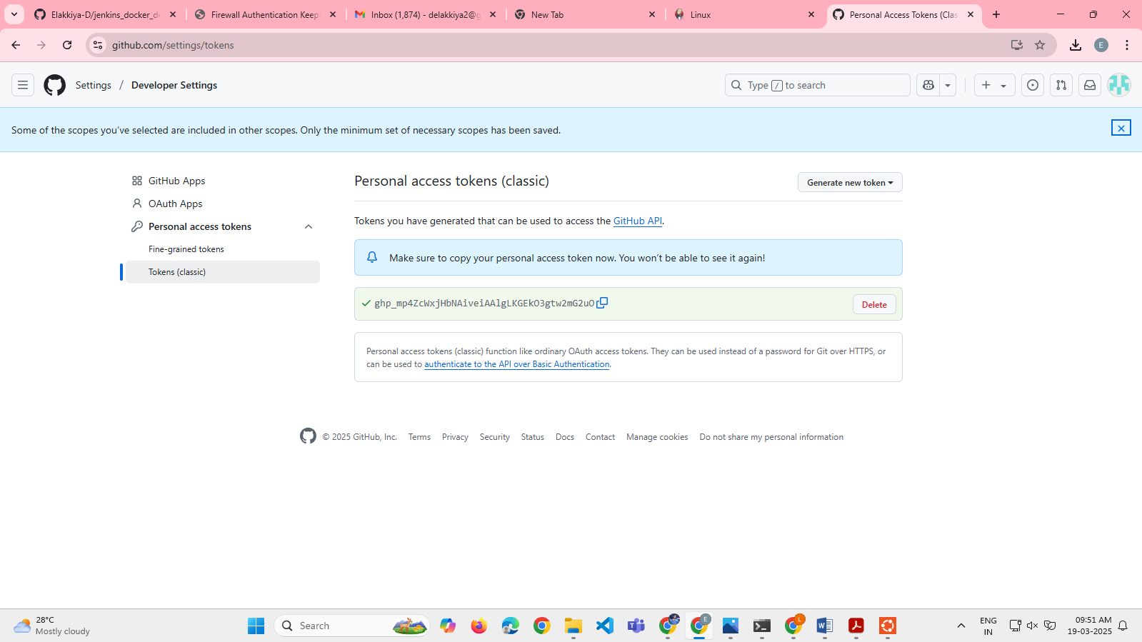

Step 5: in Jenkins configure save it

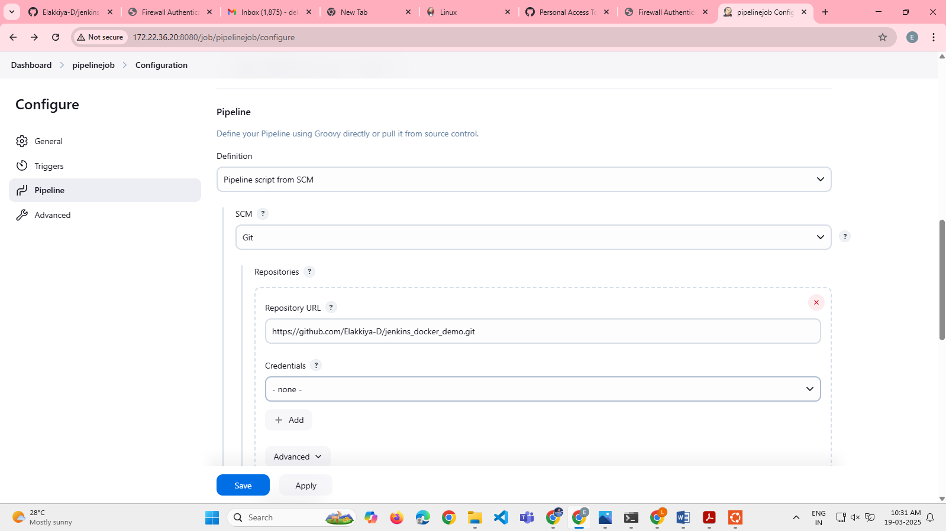

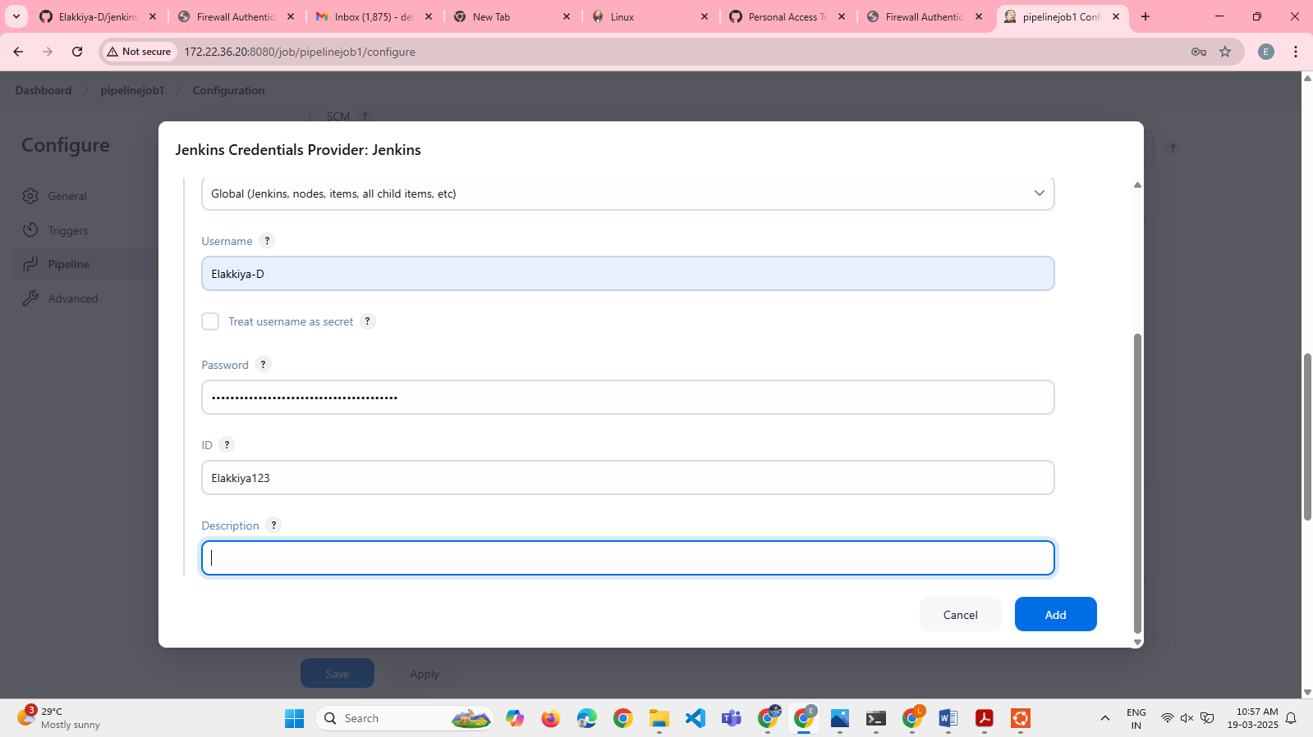

Step 6: verify the status page

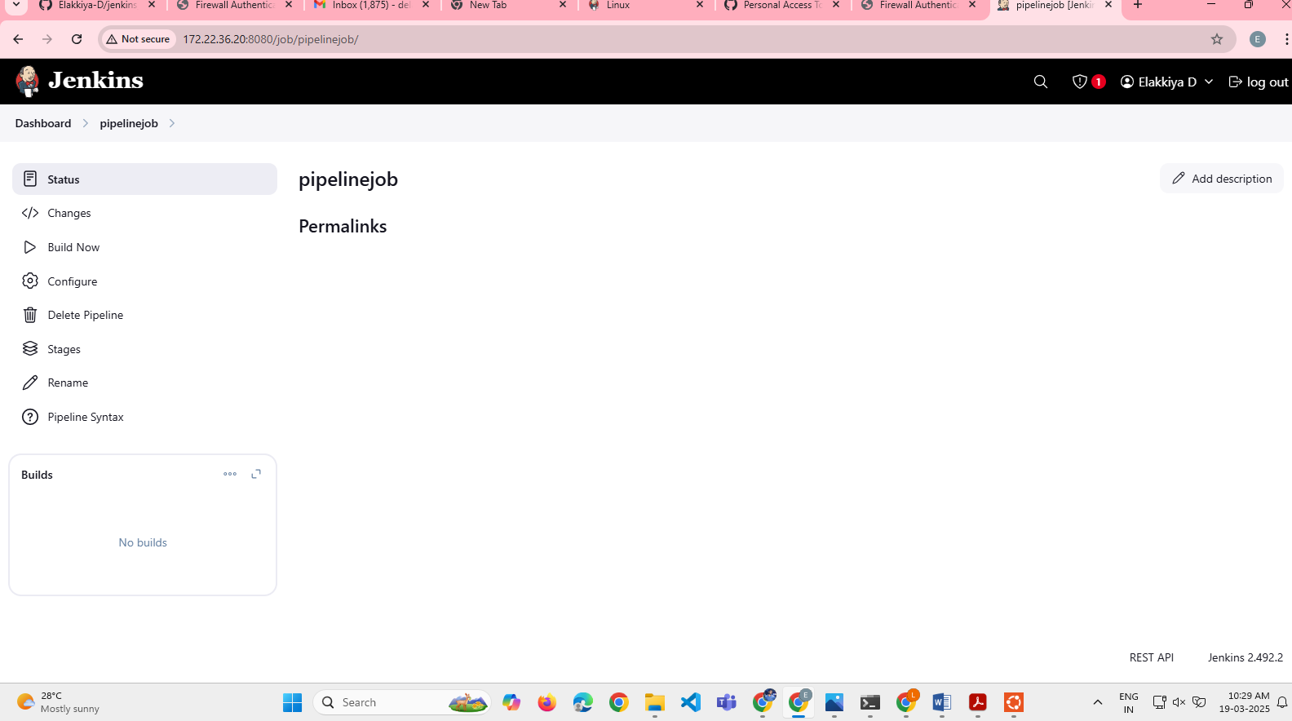

Step 7: clone the git repository

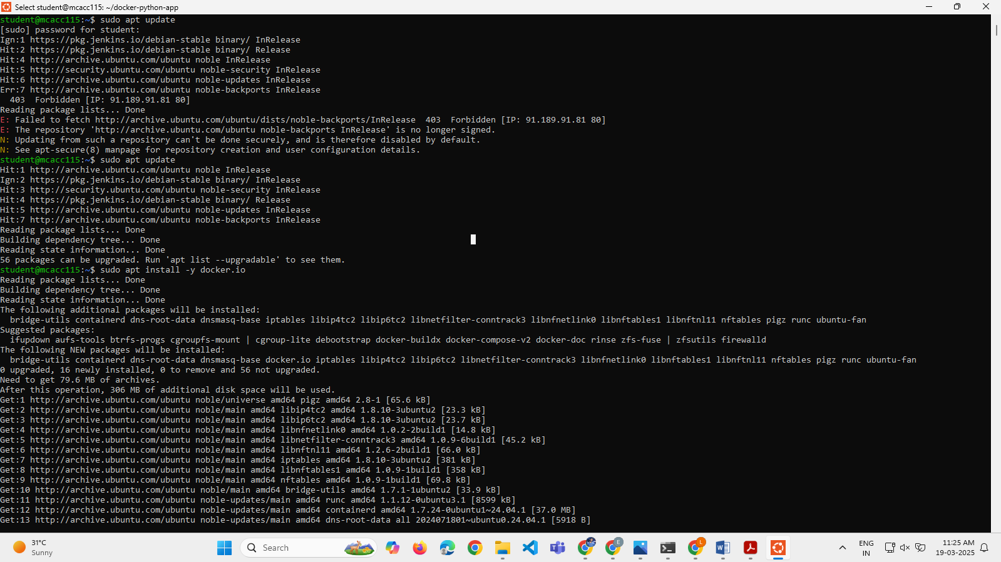

Step 8: using cd add the repository into it

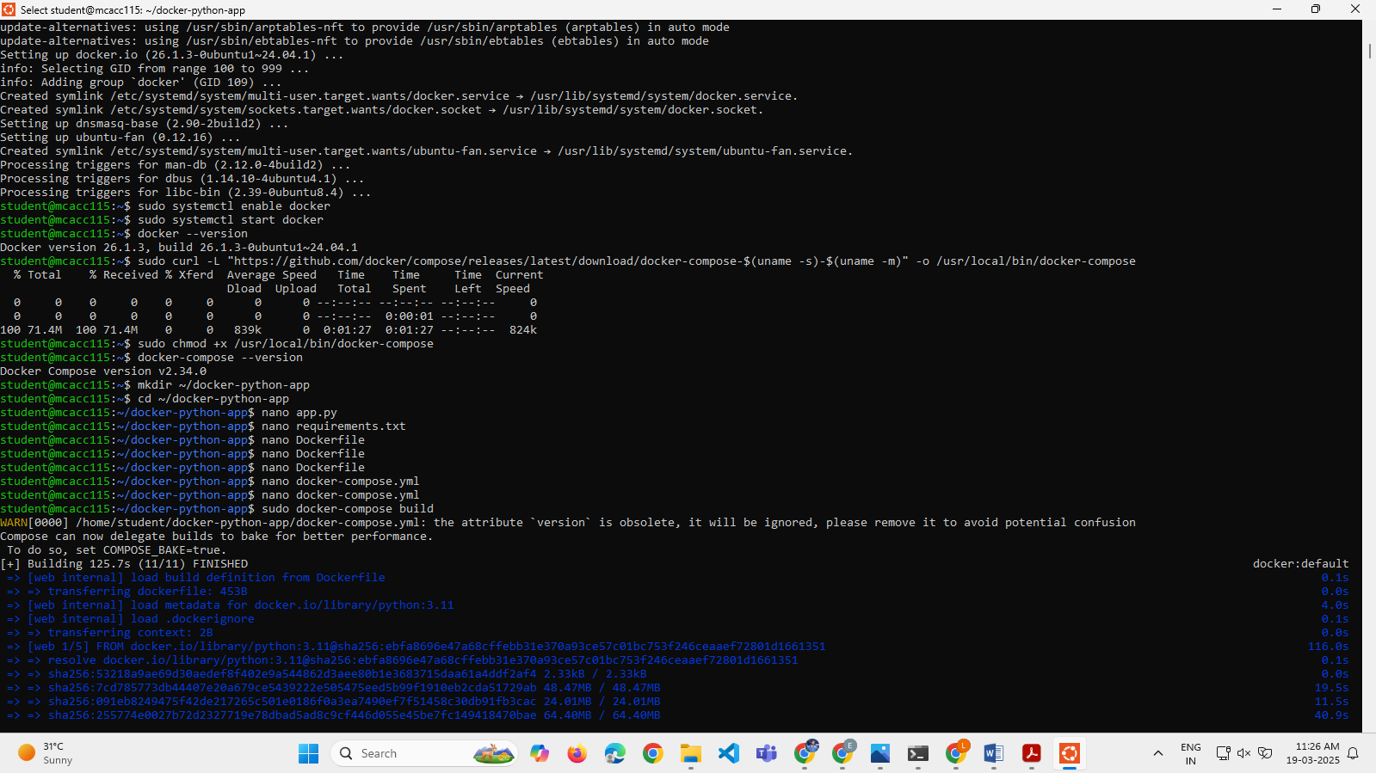

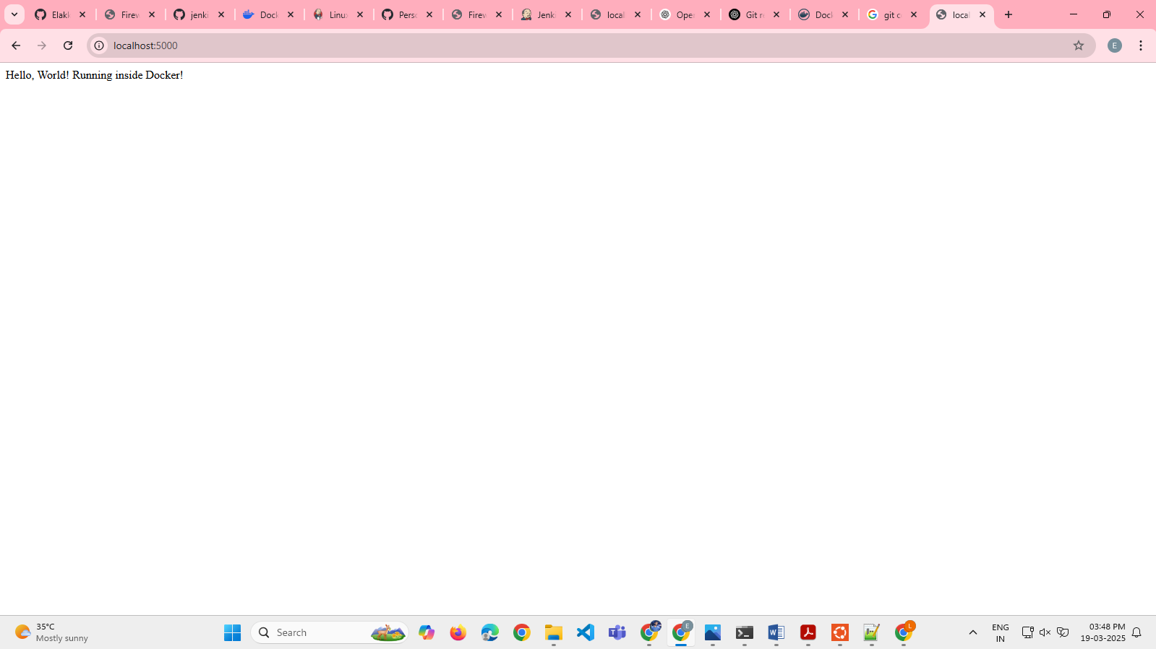

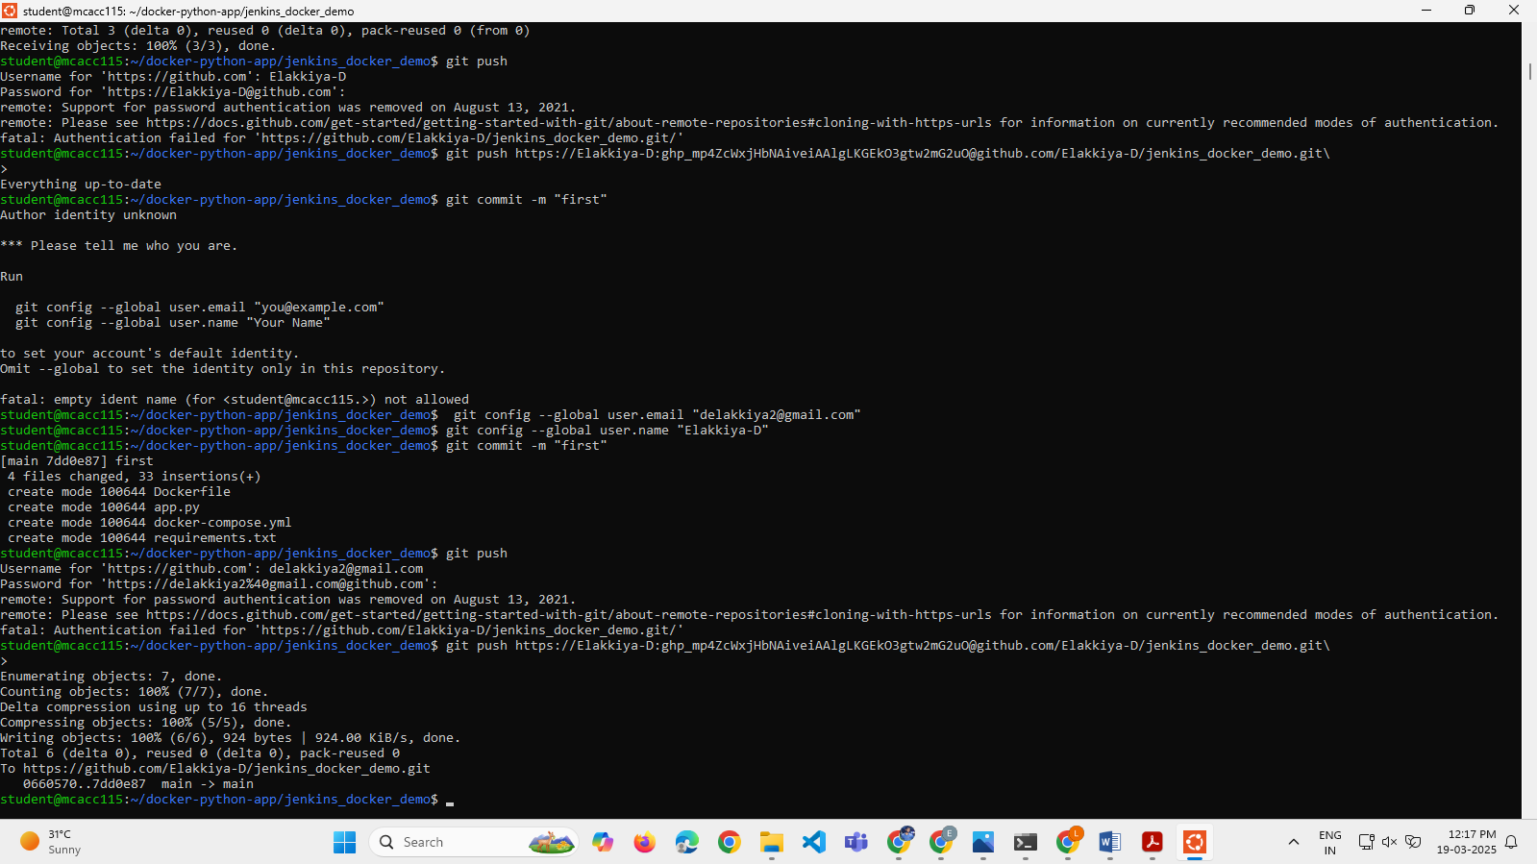

Step 10: check the docker all the files are uploaded in the github repository



Step 11: go to the docker and login in 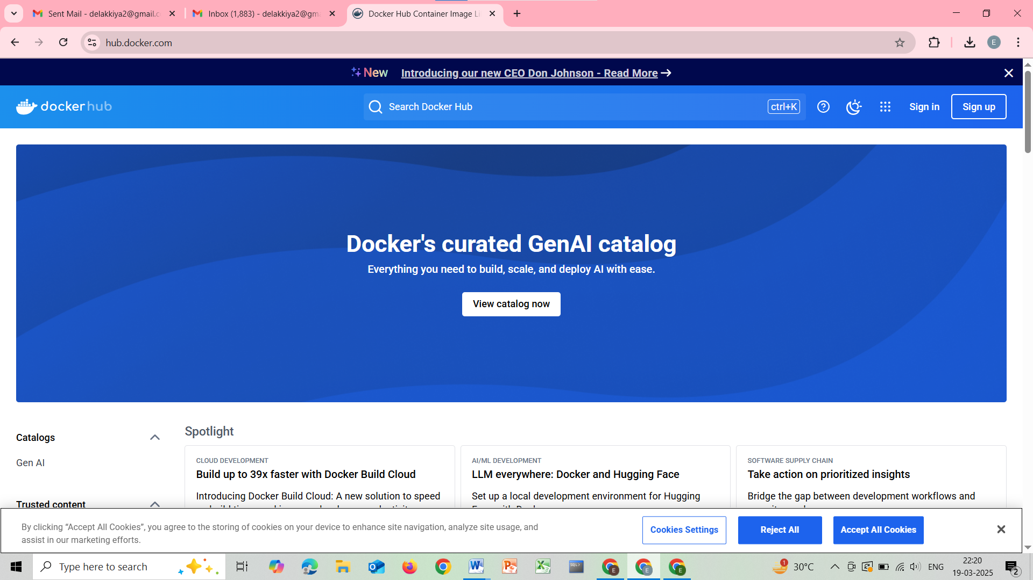Step 12: in jenkins copy the global credentials and change in the jenkins file

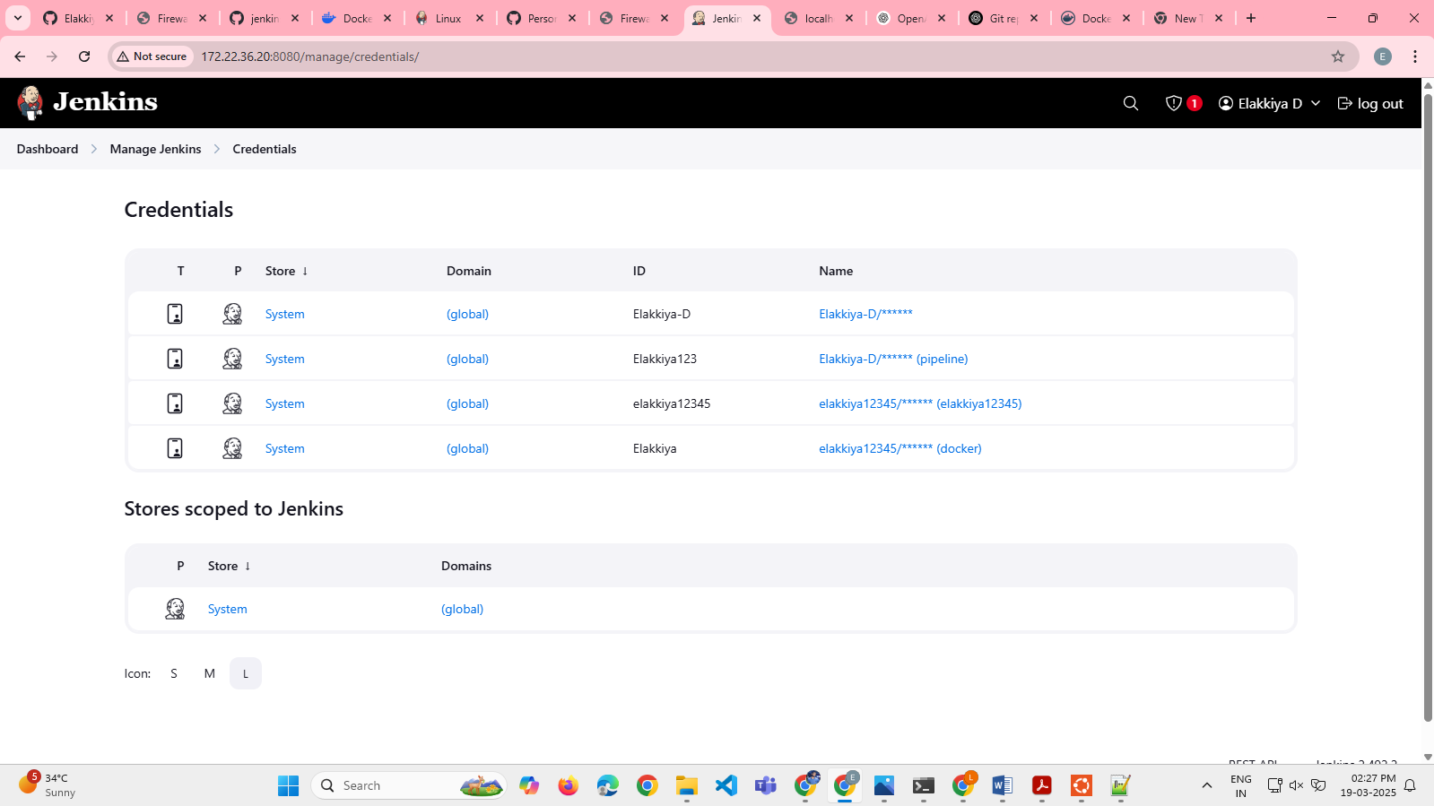

Step 13: commit the jenkinsfile into github

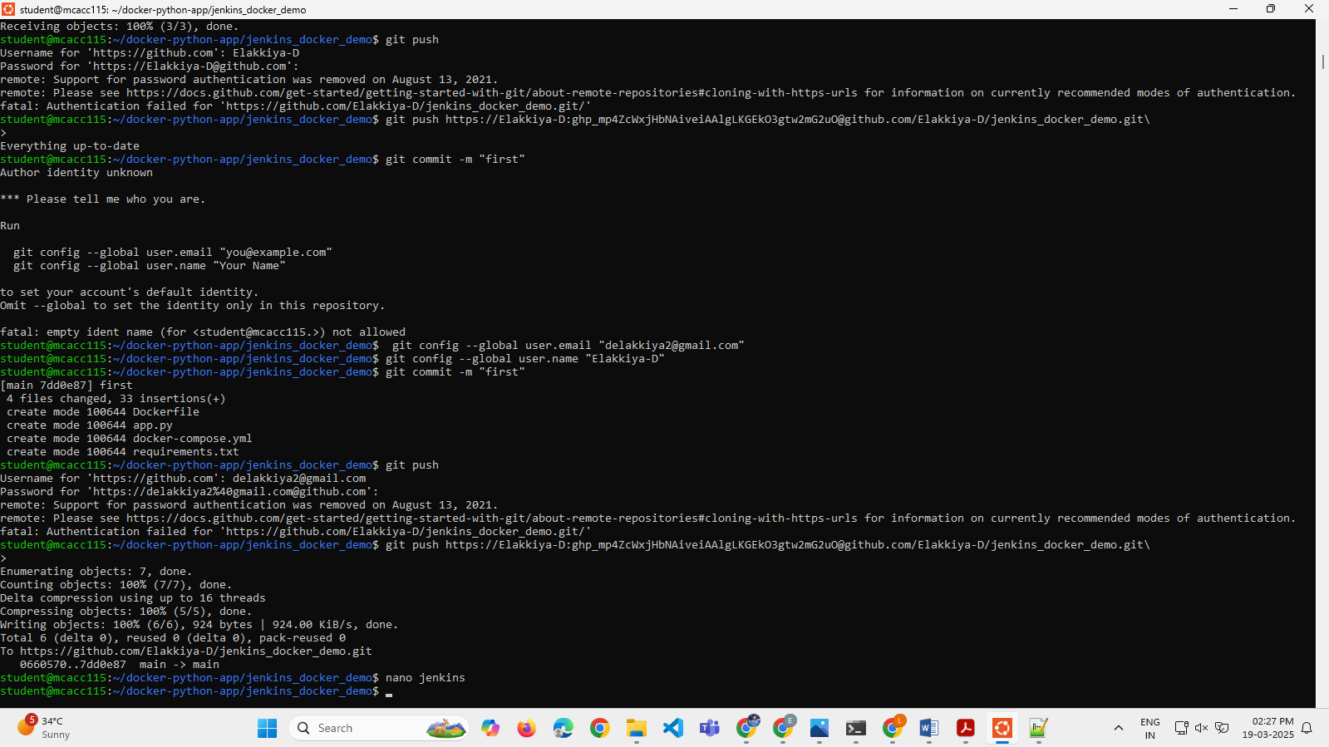

Step 14: verify the jenkins file is pushed in the github

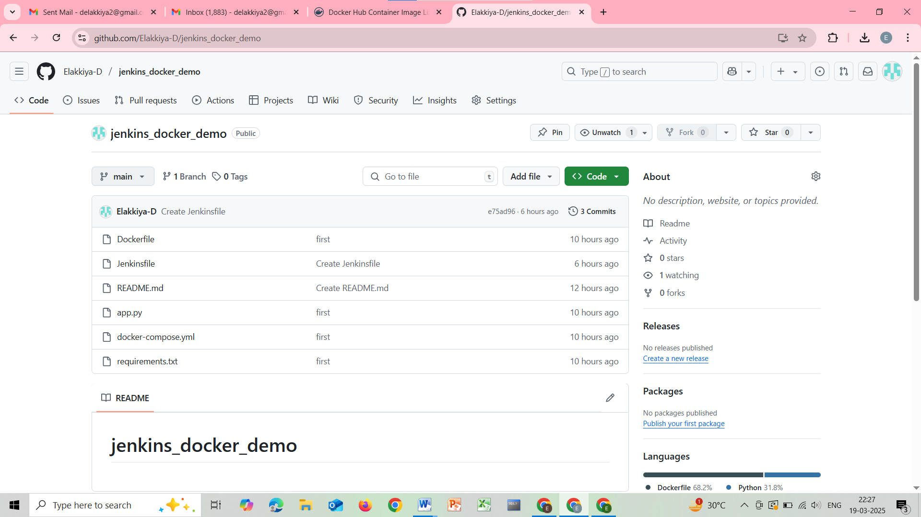

Step 15 : using “sudo usermod –aG docker jenkins” and restart the jenkins

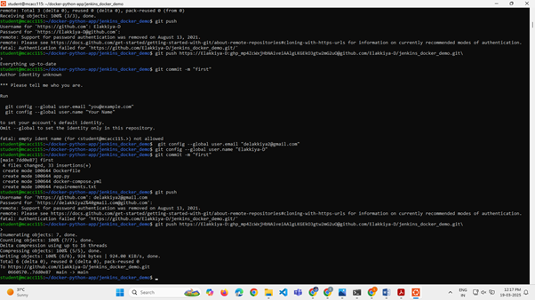

Step 16 : build the item and check the output in console output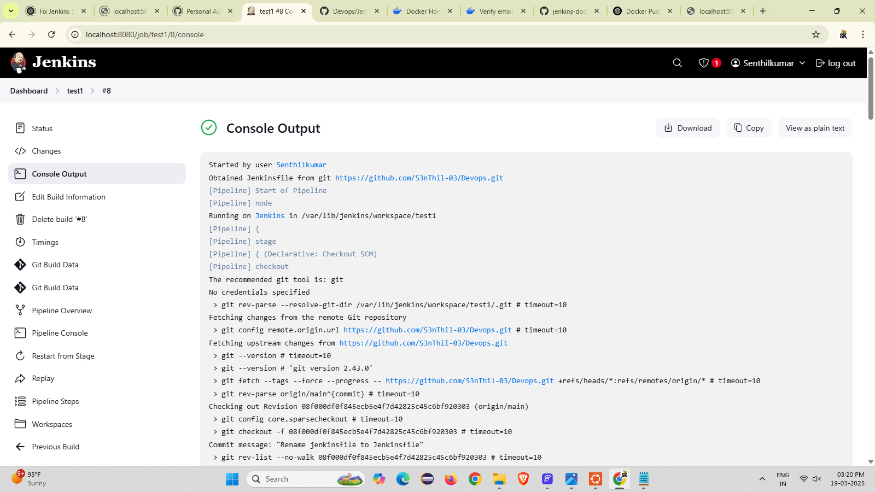

Step 17 : run the localhost:5001

